Gyakorlat 8

<https://mongoplayground.net/>

db.collection.find({},

{

firstName: 1,

lastname: 1,

user_id: 1,

_id: 0

})

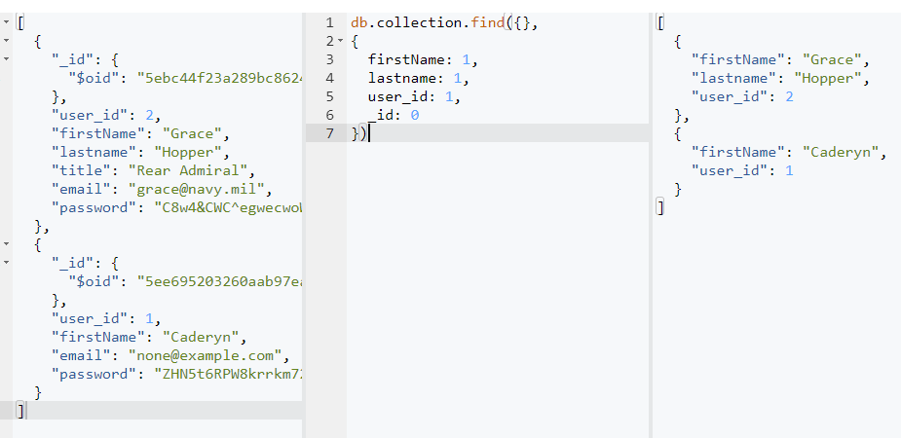

db.collection.find({

firstName: "Grace"

},

{

email: 1,

password: 1,

_id: 0

})

